2024 Nominating Committee Report
April 16, 2024
The Nominating Committee is pleased to recognize and thank the officers whose terms in office do not expire until June 30, 2025: Christine Schmitz, Treasurer; Diane Roca, Secretary; Roxann King and Judy Carbone, Co-VP Public Policy; and Jeanne Blades, VP Membership. All position descriptions are posted on the AAUW MD website: https://aauw-md.aauw.net/about/handbook/
The 2024 Committee respectfully nominates the following candidates for the July 1, 2024 – June 30, 2026, term, except, as noted, Susan Wierman is nominated for one year:
- State President: Heather Reichert (Gaithersburg Branch)
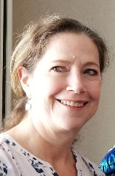
Heather Reichert previously served as Co-Vice President of Programs since July 1, 2022. She also served four years as branch president and four years as VP of Programs for the Gaithersburg Branch. Heather was also Co-Secretary for AAUW Maryland a few years ago. Heather earned her bachelor’s degree from American University in Washington, DC, and master’s degree from Johns Hopkins University. She has worked in the property tax area of the real estate industry, including 25 years at Marriott International headquarters in Bethesda and now with Ernst & Young in Tysons, VA. She is active in professional organizations including having been the Chapter Chair for the DC area chapter of the Royal Institution of Chartered Surveyors (RICS), an international property standards organization. She has lived in Montgomery County for over 30 years and is originally from the Philadelphia area.
- Vice President, Programs: (Continuing to seek nominee)
Two provisions of the Bylaws apply to this situation:
- Nominations in addition to those previously presented by the Nominating Committee may be made from the floor at the annual meeting with the consent of the nominee.
- All vacancies in office shall be filled for the unexpired term by the board. (This would need to happen if we can't elect a new President at the Annual Meeting.)
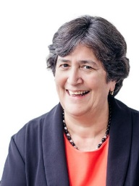
- Vice President, Funds: Jeri Rhodes (Kensington-Rockville)
Jeri Rhodes is retired and lives at Leisure World in Silver Spring. She has been a member of the Kensington-Rockville Branch and has served as Branch President and as Treasurer at various times. She has also served on the State Board as Secretary. Jeri spent much of her career leading the administrative and financial operations of law firms in Washington, DC. Most recently she served as CFO for the Friends Committee on National Legislation (a Quaker lobbying firm), and as Chief Financial Officer of Greenpeace. Early in her career she served as Treasurer of St John’s College. Most recently, she served on the Board for March for Our Lives, a youth-led organization that came out of the Parkland shooting. She was also active as a Board member of VGIF, an organization that provides community funding for projects that improve the lives of women and children all over the world. Jeri has earned the CPA and CMA designations and is a graduate of American University in Washington, DC, and the University of California, Riverside. She is a long-time resident of Kensington, Maryland and has two adult children, Matt and Keith, who also live in this area.
- Co-Vice Presidents Communications: Lydia Alcock and Susana Hernandez Martin (Baltimore) for 2024-2026 and Susan Wierman (Baltimore) for 2024-2025
Lydia Alcock and Susana Hernandez have served as Co-Vice Presidents for Communications since August, 2022, responsible for the AAUW-MD website. Both have agreed to serve a second two-year term. Susan Wierman has completed two terms as Co-VP Communications, and the AAUW MD Board has agreed to suspend the two-term Bylaws limit, so she is nominated and has agreed to serve one additional year as Co-VP with Lydia and Susana. Susan prepares the Marylander and Counterparts Directory, sets up Zoom calls, and sends communications to members and the Board.
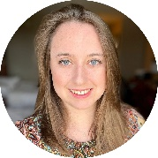
Lydia Alcock is the Director of Operations and Marketing at Maryland Nonprofits. With more than 12 years of experience in the nonprofit sector, Lydia held positions at several organizations, including Maryvale Preparatory School, Port Discovery Children’s Museum, and the Smithsonian Center for Learning and Digital Access, before joining the Maryland Nonprofits team in 2016. In her leadership role, Lydia guides marketing department projects and workflows, fostering a collaborative team spirit and ensuring alignment with overall priorities, goals, and milestones. Born in England and raised in New York, Lydia’s journey led her to Baltimore in 2008 to earn her B.A. from Johns Hopkins University, where she studied Psychology and Museum Studies. In her personal life, Lydia enjoys creating art, traveling, and supporting animal rescue efforts.
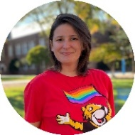
As Communications Fellow with Maryland Latinos Unidos, Susana Hernández Martín creates bilingual marketing materials promoting the organization’s programs and initiatives. She previously served as a communication coordinator for Abriendo Brechas de Colores, a nonprofit in Cuba that fights for the rights and well-being of LGBTQ+ Christians. She is also the founder and co-director of “Q de Cuir”, the only magazine in Cuba dedicated to and produced by members of the LGBTQ+ community. Hernández Martín earned a Master’s degree in Women’s and Gender Studies at Towson University and was an American Association of University Women International Fellow in the 2021-2022 school year. She earned a bachelor’s degree in journalism from the Universidad Central “Marta Abreu” de Las Villas in 2012.
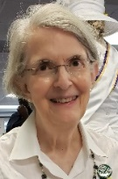
Susan Wierman joined AAUW in 1995 and has served in various leadership roles, including Co-President of the Baltimore Branch and Co-President of AAUW MD. A Pacific Northwest native, her B.A. and Master’s in Urban Planning are from the University of Washington. She worked for local and state agencies in Washington and Minnesota before moving to Maryland in 1981. Employed by the Maryland Department of the Environment for 15 years, then serving 21 years as Executive Director of the Mid-Atlantic Regional Air Management Association, she semi-retired 2017. She continues to teach “Principles of Air Quality Management” in Johns Hopkins University’s online Engineering for Professionals master’s degree program. She is an active member of the Air and Waste Management Association. She and her husband wish they could see more of their son, daughter-in-law, and three grandchildren, who all live in California.

- Nominating Committee 2025: Anita Rosen (Kensington-Rockville), Edie Allison (Gaithersburg), and Bev Fallik (Howard County), plus Susan Wierman (ex officio as chair of this year’s committee)
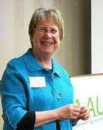
Anita Rosen is a retired Gerontologist and educator who now works as a professional, unpaid volunteer. In her former life she directed a national gerontology curriculum project for the Council on Social Work Education funded by the John A. Hartford Foundation to infuse aging content into the basic social work curriculum. In that capacity, she directed research, developed curriculum and lead training for over 400 faculty. Prior to CSWE she was Senior Staff Associate in Aging Policy and Practice for the National Association of Social Workers. Other work includes international health care financing and management, over 20 years of teaching social work and health care administration on the graduate and undergraduate levels, work as a public health program director, and as a high school English teacher. Her social work career began at Jane Addams’ Hull House in Chicago, the first settlement house in the US. Anita has been an active member of AAUW for several decades, serving as branch president (3 times), branch program VP (4 times), and State VP of Public Policy. Also, she is the proud grandmother of two granddaughters and three step-granddaughters ranging in age from 16-25 years, and she strongly believes in the benefits of intergenerational activities.
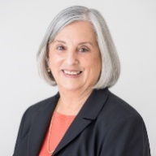
Edie Allison is semi-retired, consulting on the geoscience underlying energy policy. She has been active in the AAUW Gaithersburg branch for 25 years. She currently is branch president and has served in other branch officer positions in the past. Her special interest is increasing the retention and advancement of women in STEM. The Gaithersburg branch holds an annual used book sale to raise money for scholarships to women pursuing non-traditional careers at Montgomery County colleges and universities. Edie has served as Maryland AAUW president, membership co-VP and newsletter editor at various times in the past. Ms. Allison has bachelor’s and masters degrees in geology. She worked as a petroleum geologist in Amarillo, Texas, and Bartlesville, Oklahoma, before moving east to work for the U.S. Department of Energy. After retiring from the Energy Department, she worked as policy director for the American Association of Petroleum Geologists and has been an independent consulting geologist for the past eight years focusing on reducing and mitigating emissions from oil and natural gas.
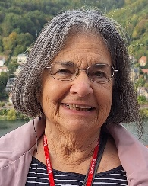
Beverlie Fallik grew up in Brooklyn and Long Island, NY in a large, warm and boisterous extended family where women and men still had traditional roles. While in high school, her Mom's advice was that you didn't need a college degree to wash dishes. So, of course, Bev went on to get her BS, MS, and PhD in Human Development. Bev held various positions, from elementary school teacher, to consultant at a residential facility for court adjudicated teens, to NIMH and SAMHSA Project Officer and Contract Manager for multimillion dollar research and evaluation programs often identifying and targeting people at risk for substance abuse and emotional disorders. She has published and given numerous presentations on related topics. After retirement, at AAUW, she served for several years as Public Policy VP in Howard County and worked to advocate at the MD Assembly for extending child support to cover post secondary education. Aside from her passion for the rights of women and for access to education, Bev enjoys spending time with her family, participating in various community support activities, and discovering wherever the path goes.
================================================================================== Respectfully submitted by the 2024 Nominating Committee: Susan Wierman (chair) (Baltimore), Pat Stocker (Bethesda-Chevy Chase), Beverlie Fallik (Howard County, and Kate Campbell Stevenson (Kensington-Rockville).

